OUT AND ABOUT 4X4 CLUB

TRIP: Gnangara Pines Night Navigation
Date: 24 October 2020
Trip Leader: Woody
Report: Chris Redgrove

Participants: Chris Redgrove, Garry Wood, Steve and Kerry, Terry and Jan, Andrew and Hertha, Doug & Wynona, Bob Dorizzi, Paul Hemmings, Bob Jones, Mike, Kirby, Lucy, and Tommy

The 2020 edition of the Out and About 4WD Club’s Night Navigation club trip started in the garden surrounds of Bob and Lucy Dorizzi’s house at Henley Brook. A lovely BBQ and drinks were provided to get the eager crew ready for some challenging driver/navigator tasks in the later evening.
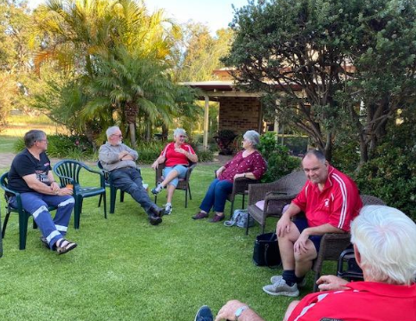

From Bob’s house, the trip organisers Woody and Chris led the team a short drive west along Gnangara Road took us to the Gnangara Pines plantation entry, the starting point for the night’s adventures.

The format for the evening was each vehicle was to follow the basic instructions on the sheet provided and answer 19 questions relating to landmarks and points of interest along the way. The intention was to have vehicles set off at 2-minute intervals and the winner would be the vehicle who had recorded the most correct answers. All very straight forward, so it seemed.
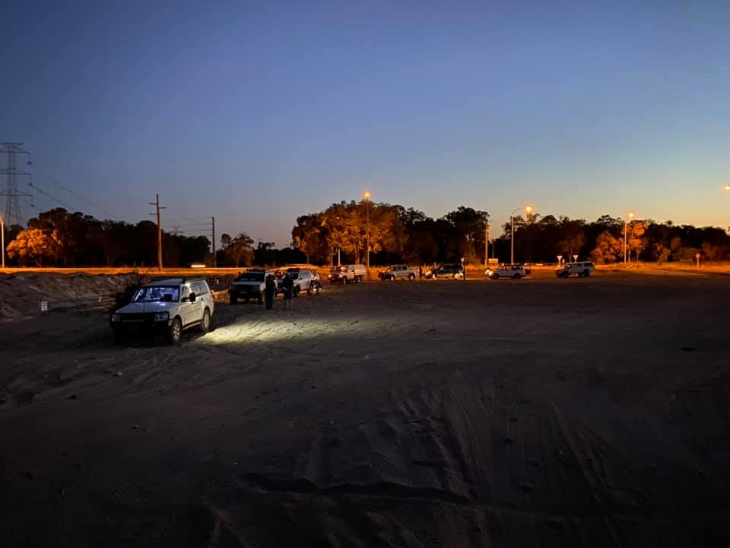

From the time the first vehicle set off and missed the first turn we knew we were in for an interesting night. From vehicles getting bogged at the first soft sand, vague instructions, incorrect tyre pressures, missing markers along the track and unskilled navigators, the comments (excuses) were many and varied.

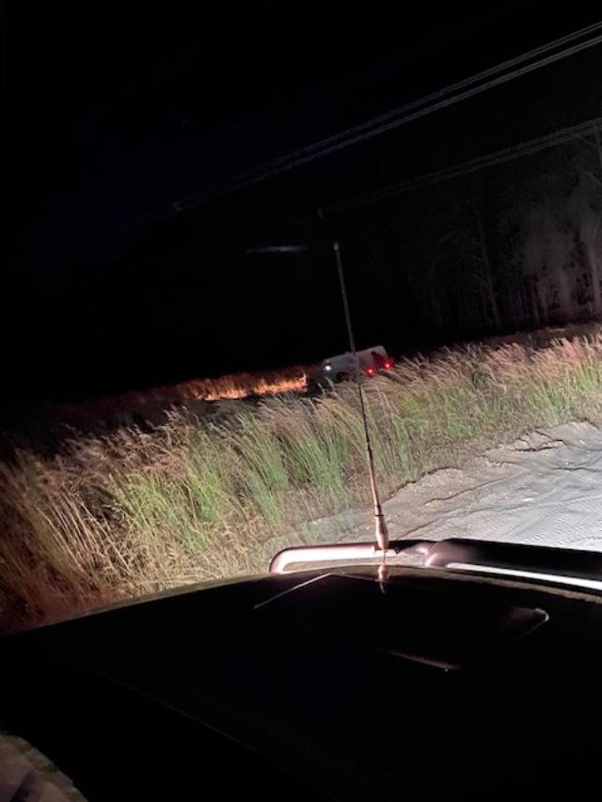
Doug and Winona quickly got things back on track after their initial mishap at the first turn and seemed to be the quiet achievers. Bob Jones and crew were taking some wild diversions and having heaps of fun along the way. Andrew and Hertha set the pace early and looked the ones to catch. Paul Hemmings went out solo and returned with a navigator, well done Paul. Kerry and Steve, well, they are back on speaking terms again. If there was a perseverance award that would go jointly to Bob Dorizzi and Terry/Jan, as nothing seemed to get in their way of finishing the course and enjoying themselves in the process.
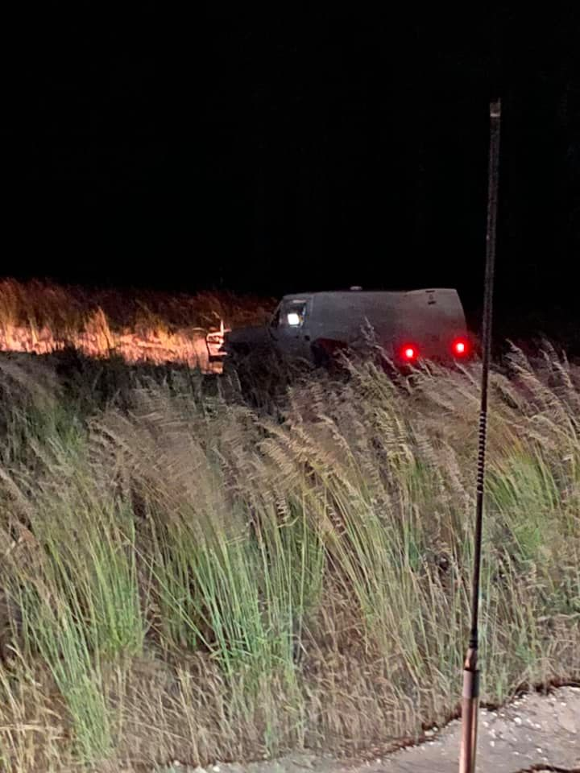

As the evening wore on participants eventually began returning and by 11:15 pm all were safely back to base. The feedback among the crew ranged from thorough enjoyment to something much different. I believe navigation training and relationship counselling were some of the terms used. 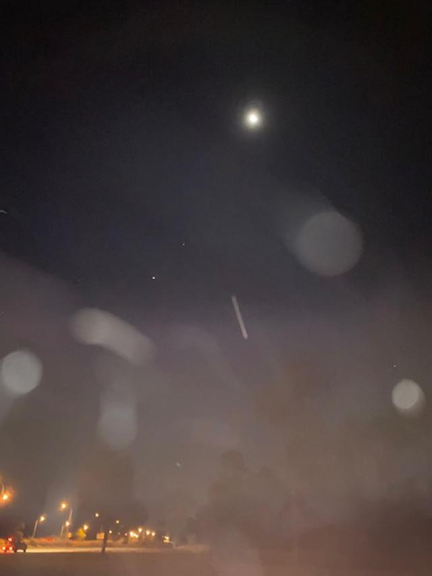
Once everyone was back, aired up and trip sheets handed in we left Gnangara Pines for another year.

The only thing left to do is announce the winner.
And the winner is ….

You’ll have to wait as it will be announced at the next club meeting along with the trophy presentation.
