Windy Harbour January 2018
2 January 2018
The trip began when we met Terry and Jan at 11:45 AM at Northcliffe. Andrew and Hertha arrived soon after. We each bought some lunch and sat at a table under a big tree near the old railway line. We were joined shortly by Chris, and then Alex and Maria and her cousin, Alberto. We left for Windy Harbour at about 12:40 PM and enjoyed the 25 km trip.
We set up our caravan/trailer-top tents and camper trailer and when Frank and Rosa arrived they set up their tent. Terri and Paul arrived before we had set our camper trailer up and that was the compliment for the night. We were all set up and sitting out by about 4:30 PM.
At 6:30-ish we departed to the Sunset Look-out and after some deliberation we stopped to watch the sun sink into the Indian/Southern Ocean. We journeyed home to the caravan park, had our dinner and sat around for a bit. By 9:30 PM most were in bed.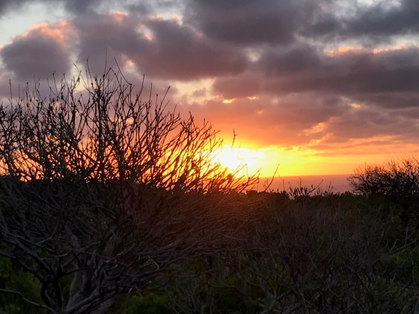
3 January 2018
Terri left for a walk at 6 AM with and the rest of the campers rose in turn to join Terry and Jan under their awning. At about 10 AM we headed off in our 4wd’s along the beach towards the Gardner River hoping to cross it and locate Moore’s Hut. The river crossing was too difficult and we re-routed and headed inland hoping to cross further along the river. We came to a river crossing but it, too proved to be too much of a challenge, so onward we went. 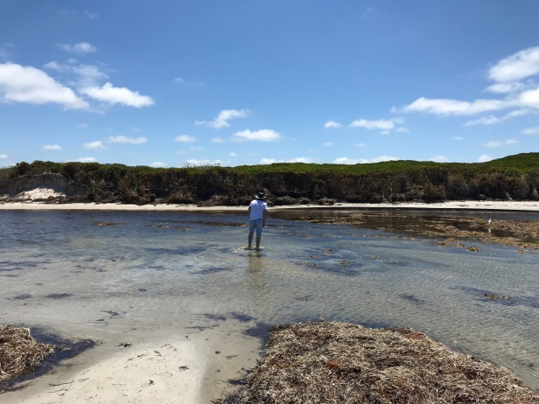
We came to a challenging overgrown dead end and had some fun turning the whole convoy around. We headed back to Chesapeake Road and made our way back to the black-top. We aired up and headed for camp.
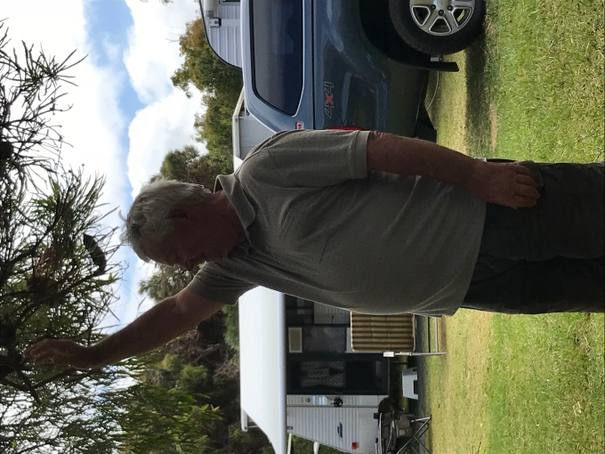
Preparation soon got underway for the evening shared meal. Just after 6:30 PM the food started arriving, lovingly prepared and shared by each camper. Terry and Jan organised a fabulous feast. They cooked lamb and beef roast and we provided all manner of vegetables and salads. This gorgeous meal was completed with a piece of traditional Christmas cake which had been seriously soaked in something sweet and alcoholic. It was a lovely shared meal and we all enjoyed some truly “believable” conversation. All turned in by about 9:30 PM.
4 January 2018.
Woody was up and ready to go fishing but when we joined him no one else had shown up so fishing was postponed.
A drive to Broke Inlet became the order of the day and Woody lead the convoy of Steve and me, Rosa and Frank, Chris, Terry and Jan and Terri and Paul. Hertha and Andrew had a trip to Manjimup for mechanical repairs and Maria and Alex and Alberto stayed at the camp for a relaxing day of swimming and reading.
Our journey included Broke Inlet, Mandalay Beach and a wicked, sandy drive in and out from Long Beach.
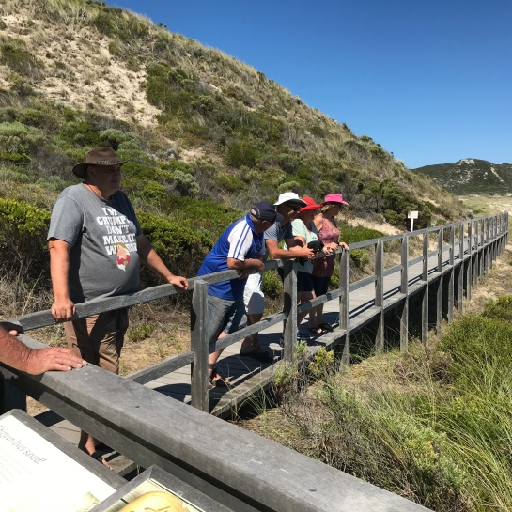

We returned to camp at about 6:45 PM. We all quickly prepare dinner, and then Terri cooked baked apples. A lively group chatted and laughed around the warming campfire. Yes it was cold.
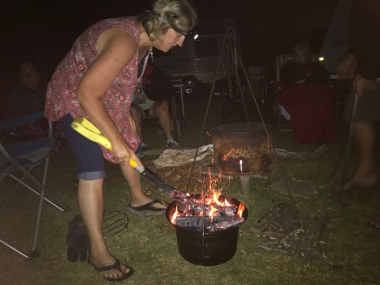
5 January 2018
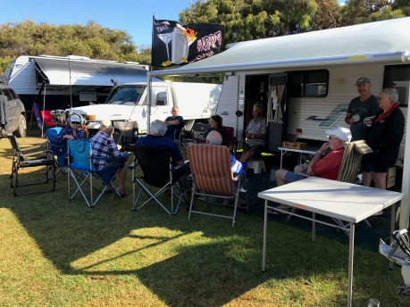
We were all awake by about 6:30 AM and congregated at Terry in Jan’s “Veranda”. There had been a very heavy dew overnight so we actually sat outside the awning while the condensation dripped onto the floor. After breakfast Andrew and Hertha had a trip to Manjimup for an auto part and Alex Maria and Alberto went with them. The rest of us sheltered out of the blustering wind and intermittent rain until lunchtime when Terry and Jan, Rosa and Frank, Woody, and Kerry took off for the Northcliffe pub for lunch. We passed Chris and Terri who had been for a forest walk to Lane Pool Falls, and were returning to camp where Steve and Paul were ‘diligently’ guarding our camp (wink, wink)
A few people sampled Mr Whippy ice-cream when we returned.
In the afternoon Paul and Terri baked awesome Rock Cakes in the camp kitchen and several folk played Mexican Domino’s until it got too serious (Ha ha).
Dinner was a hurried affair dodging cold wind and then a bit later the rain sent us sheltering into our homes.
A few diehards stayed around the unlit fire pit telling stories of life experiences and sharing opinions on anything and everything. Coldest day so far.
6 January 2018
Team meeting at Terri and Jan’s at about 6:30, the usual “Good Morning” whilst people woke up, made coffee and joined the group. Paul and Terri left for home today and Chris a couple of hours later. It was decided that the rest of us would take a drive to the beach via the Summertime Track. Woody was the leader and he was followed by Jan and Terri, then Alex and Maria and Alberto, then Frank and Rosa, Steve and Kerry, and Andrew and Hertha were Tail-end Charlie. It was quite a long drive in, with few challenges until we got to the sand dunes. First Woody got stuck on top of the dune, and then Terry had forgotten to put his ute in four wheel drive. He was fine once he did that, then Alex got stuck at the last hurdle. Frank went up and over and Steve did too except for a right bank that got a bit too close and did damage to the front parking light housing. Finally Andrew made it up and over and we were all ate on the beach.
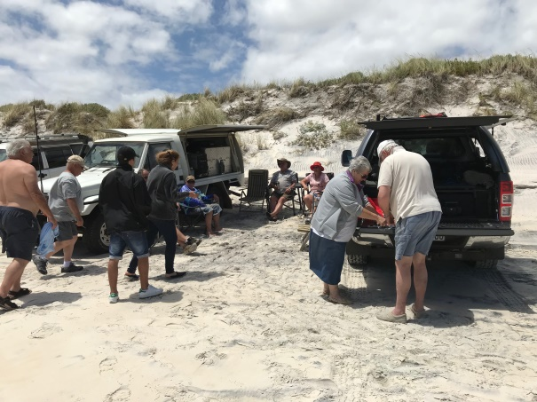
We sat between two cars for protection from the wind while we ate our lunch. It was beautiful on the beach and we were reluctant to go, but go we did and apart from needing to stop and pump up tyres a bit, it was a relatively easy return. We aired up at the roadside stop and headed for home. We were pretty quick to get down to Mr Whippy when we got back and it was well worth the dash.
We sat out together for a bit then got tea. Some people cooked on a hot plate on the fire which we had lit. It got colder and colder as the evening progressed and we were all squared away by about 9:30 PM.
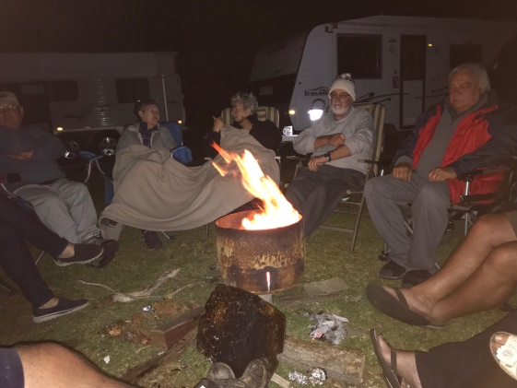
7 January 2018
The campsite was busy early as people packed up ready for departure. Only Andrew and Hertha were staying on a little longer. We had all set off by about 9 o’clock and sad to end a lovely getaway to the south west corner of the world.
Thank you, Terry and Jan, for organising another great windy Harbour trip.
