Steve’s Foray into the Mundaring Forest 25 March 2018
By Chris Redgrove

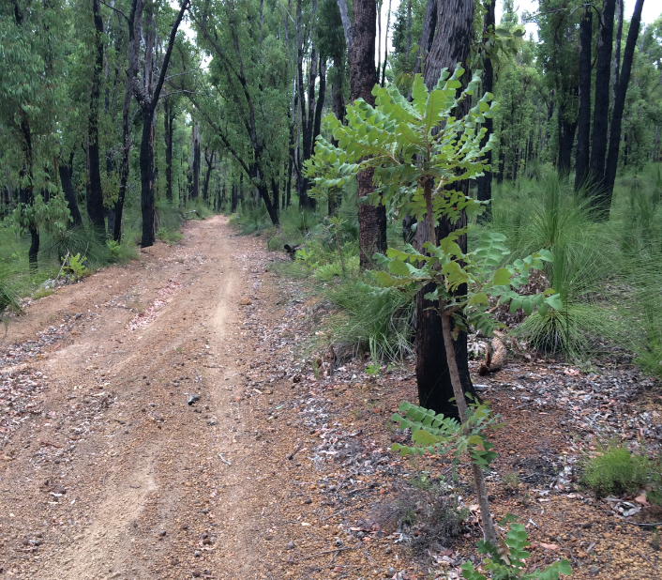

An overcast, mild morning greeted those attending the Out and About Club’s March 25 trip into the Mundaring Forest. After formalities and a minor altercation between Mike and a wayward willie wagtail a convoy of five vehicles set off from the car park opposite the Mundaring Hotel. The convoy was made up of three different types of Toyotas, one Isuzu and one Nissan. Not a Jeep in sight to the relief of some. Steve and Kerry were our very capable trip leaders for the day but to change things around from the usual order of things Steve would be navigating, apparently for the first time, ever. This didn’t seem to bother anyone at the time of being announced but things didn’t look so good when the convoy, which hadn’t yet left the bitumen to air down, found itself turning around after missing the turn off into the forest. Things could only get better from that point.
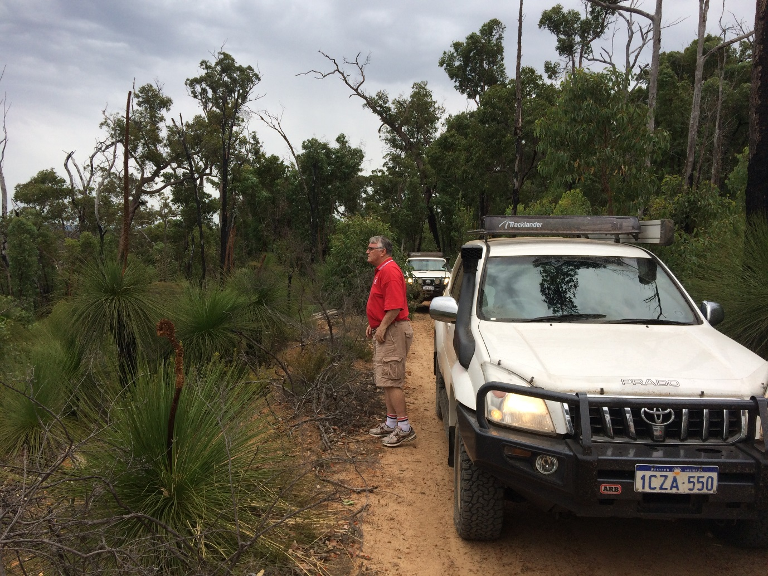
Where the @#$%^& are we?
After airing down, the group spent a fantastic morning wandering through the maze of tracks that criss-cross the forest. The Nissan Patrol initially had resistance to being put through its paces but was soon persuaded to come along and behaved itself well for the rest of the day. Some of the tracks were very narrow and a challenge to navigate while others meandered along with beautiful contrast between pine forest, natural eucalypts and rugged rock formations, all of which made it a great experience to be out driving.

A real highlight of the day was testing the capability of both driver and 4WD in an area that has come to be known as ‘The Playground’, just off the main track. This is an area of approximately 60 – 70 meters of fairly steep, loose rock and a good deal of care and skill is required to make the ascent to the top and then to safely navigate back down to the main track, low range first gear being the preferred choice. The Hilux, having met the challenge on a previous trip, wasn’t enticed to go up on this occasion. While all other vehicles conquered ‘The Playground’ the Landcruiser and Nissan got up the hill and back down with particular grace and ease. For vehicles/drivers of Isuzu and Prado, let’s just say there’s a little more work to do but thankfully we have patience.

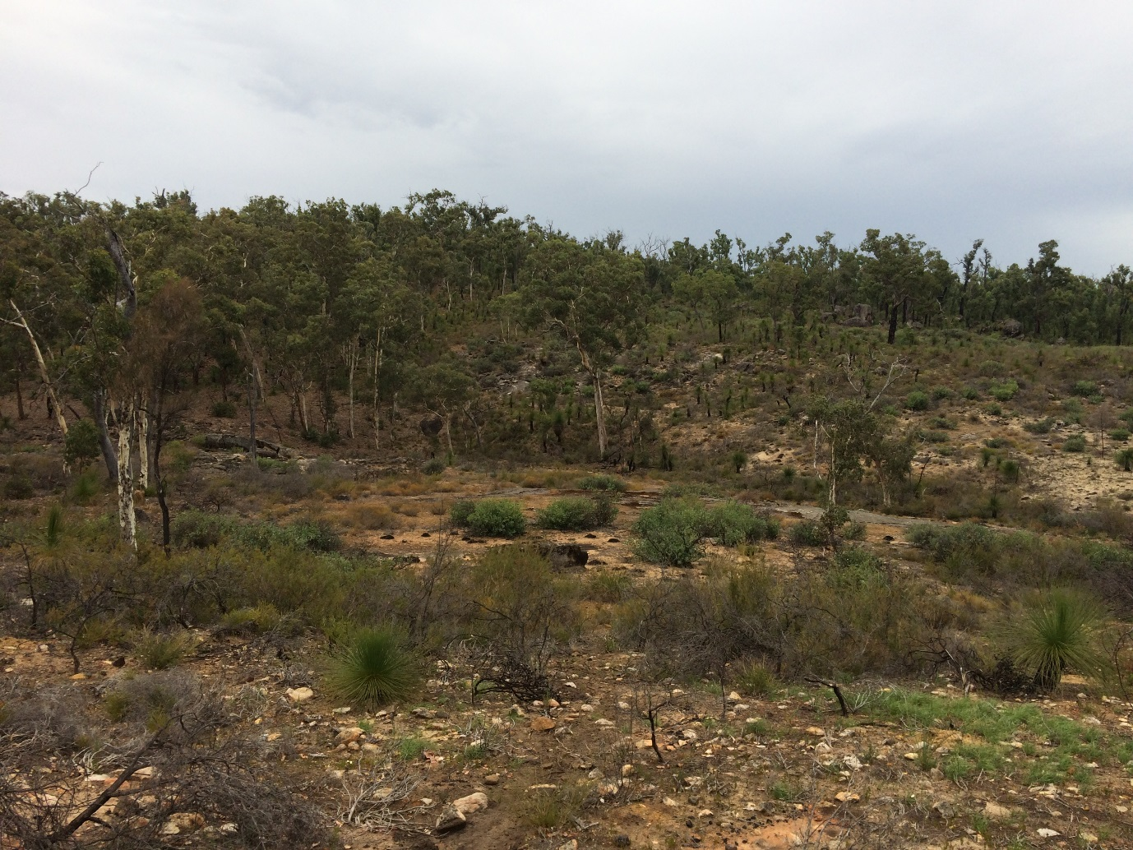

And so at around 1:00 pm with the planned trip completed we decided to drive back towards the main road and air up. Our final approach seemed to be going well until half of the convoy, due to factors completely out their control, decided to take a more scenic route back to civilisation. This eventually resulted in yet another 360 degree turn on a remote track and eventually re-joining the rest of the group. Due to the well-known sensitivities of Isuzu drivers no names are mentioned here but a re-reading of convoy procedure may be in order for some.
With one final 360 degree turn on the approach to the Mundaring Weir Hotel to keep things interesting, a much deserved coffee/beer/milkshake at the legendary watering hole was enjoyed by all.
Thanks Steve and Kerry for another enjoyable trip to the forest.

