OUT AND ABOUT TRIP REPORT
By Doug Brown
TRIP: Mundaring Weir water catchment area

Date: 10 February 2018

Trip Leaders: Kerry Gillies and Steve Dickens

At 8:30am, members gathered at the Mundaring Hotel for a drive along tracks east of Mundaring Weir. Ten vehicles took part in the event with all leaving the Hotel’s carpark at 9:00am as planned. Two visitors (Paul’s niece, Krystal & her partner Steve and Paul’s daughter Natasha Morrison) also took part in the trip. Mike and Clare volunteered to be Tail End Charlie.

The convoy’s run out of Mundaring township would have been uneventful except for directional errors by the Trip Leaders. (Muttered excuses heard over the two-way radio included “I thought there were only two roundabouts not three”.) After completing a U turn in a dead-end street the convoy at last found itself on Mundaring Weir Road where it proceeded along until turning into Firewood Road. The convoy then stopped to air-down (see below).

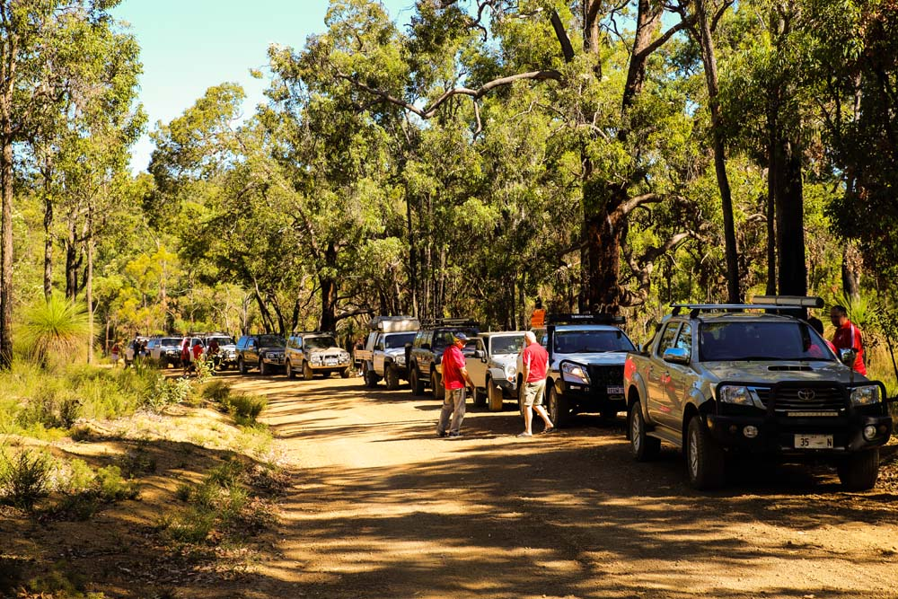

After airing-down the convoy left Firewood Road and drove down numerous tracks which included steep and/or rocky inclines and descents. Some tracks were also rutted and eroded (see below).

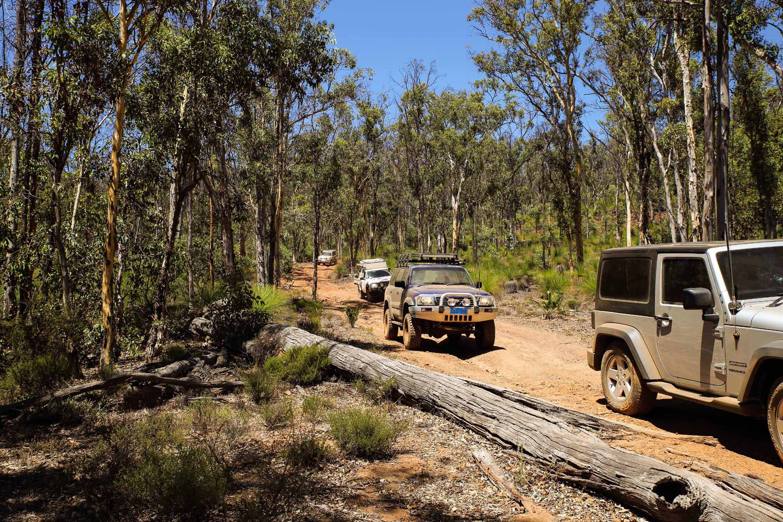

Before the trip commenced, members were advised pin striping was likely owing to the nature of the tracks. This proved to be the case as the convoy had to travel down tracks which had dense undergrowth on either side.

A member jokingly claimed the convoy seemed to be driving around in circles after making a series of right hand turns. The trip leaders concurred.

The convoy stopped for morning tea in a grove of Wandoo trees (see below) after driving 90 minutes or so. The break was well-timed given what was waiting for members in the next leg of the run

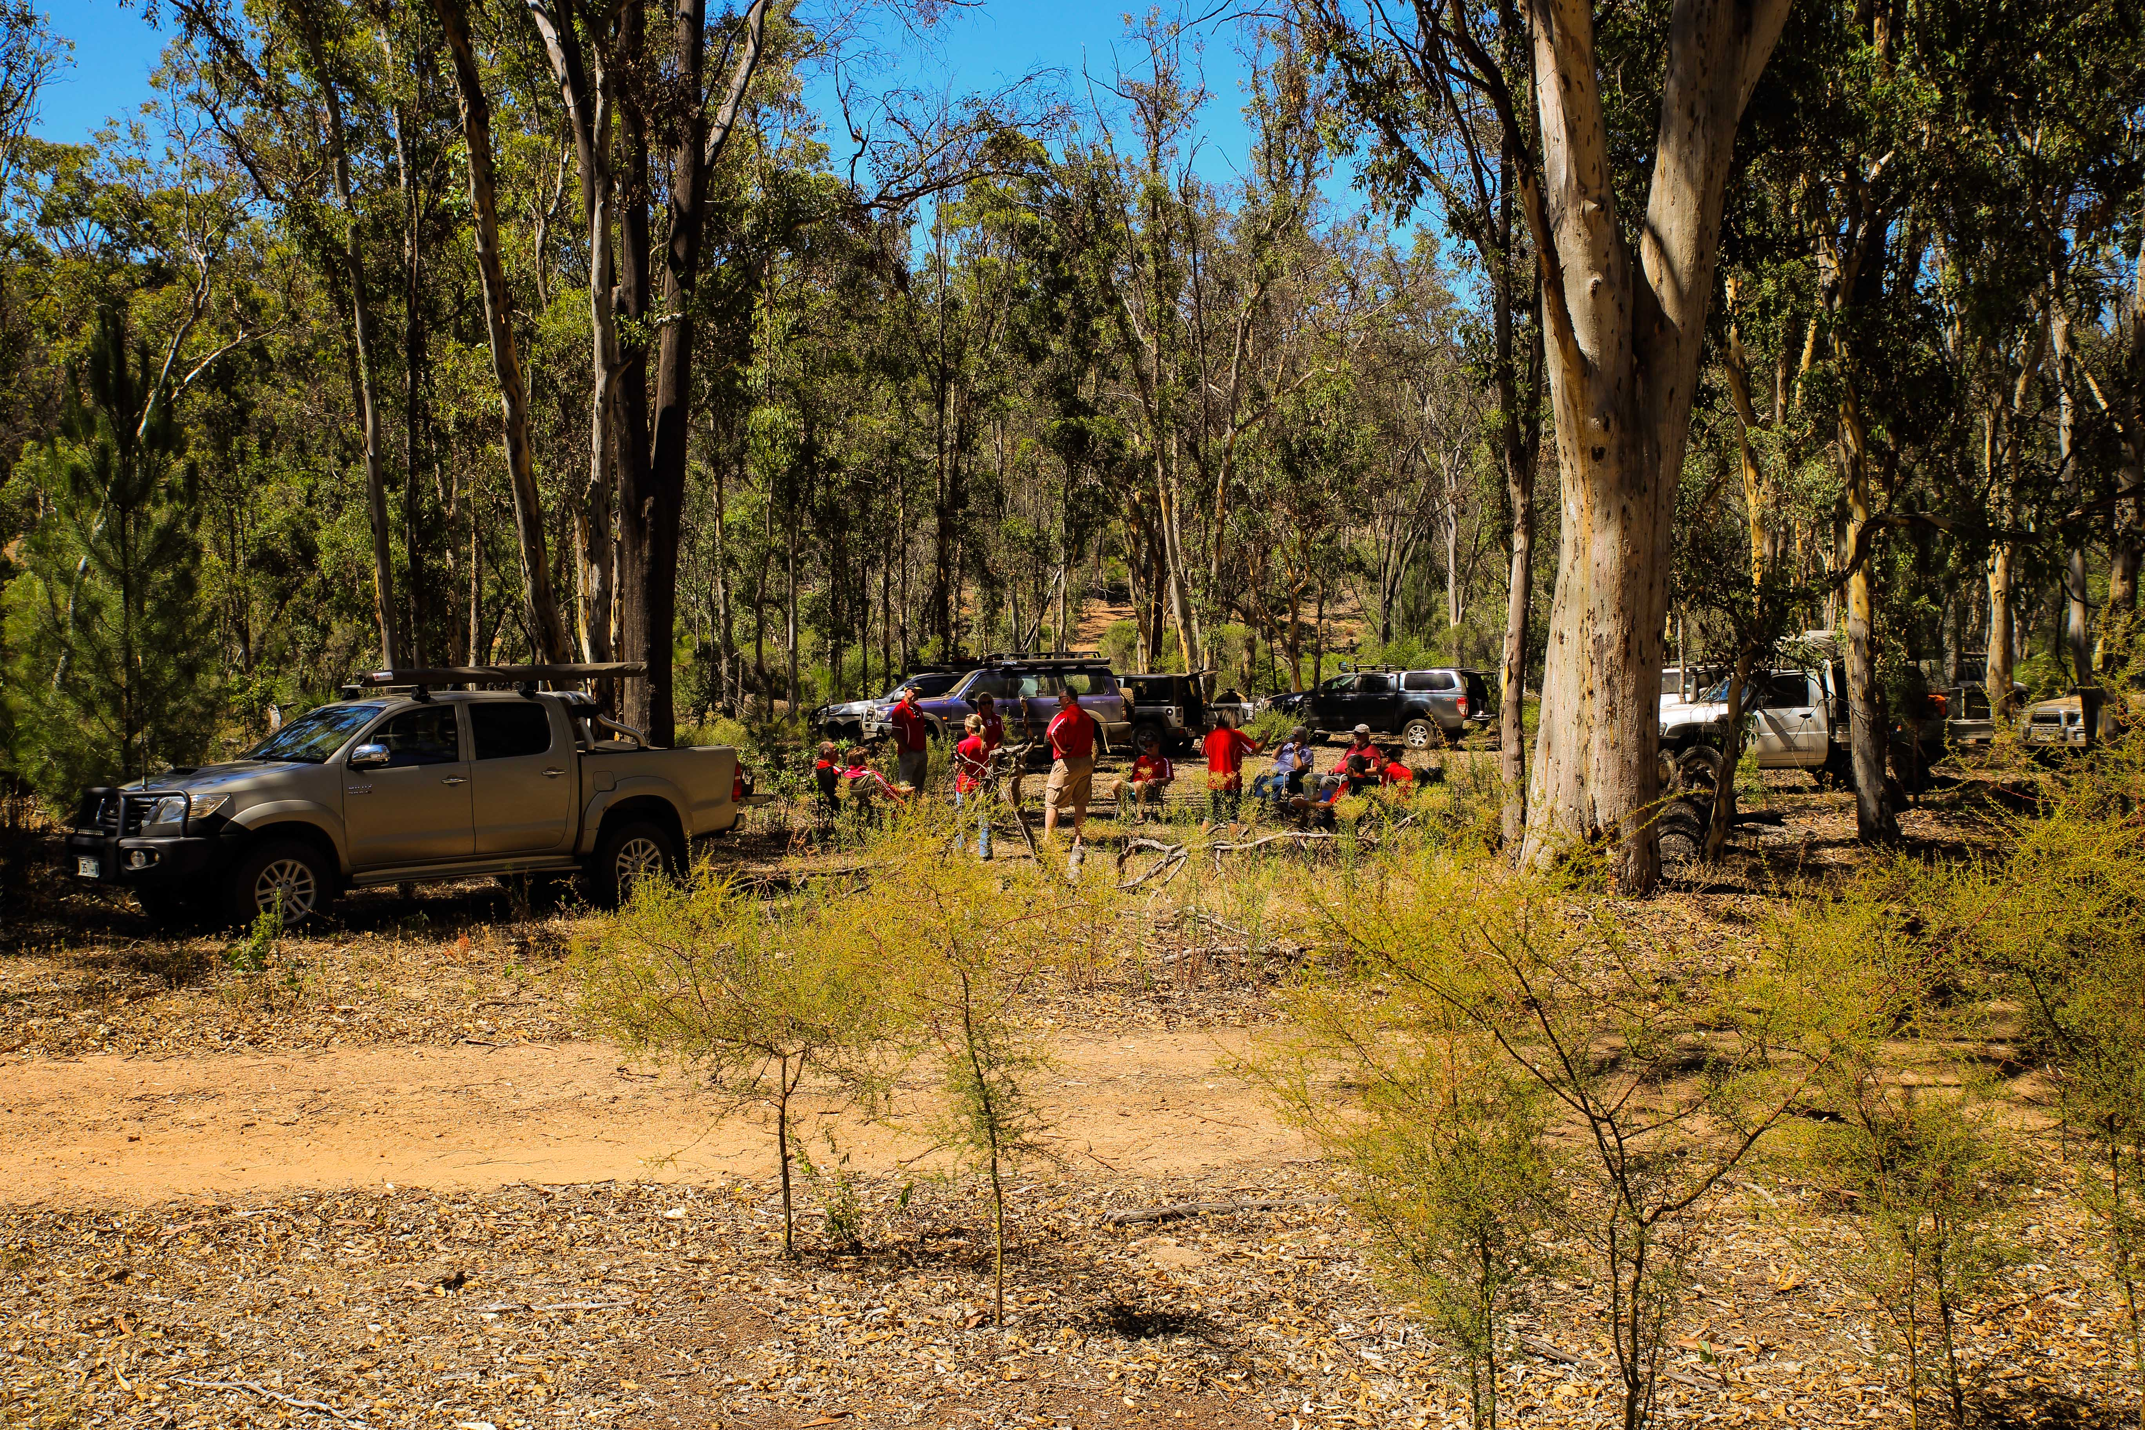

Once morning tea was over it was back on the tracks. This time members were challenged by fallen trees brought down during a recent fire in that part of the water catchment area. The biggest challenge was a track blocked by fallen trees leading to the convoy agreeing on making a by-pass track through a burnt-out pine plantation to another track. Stephen Braddow with help from other members picked out a line that could be taken by the convoy steering around fallen branches and burnt out stumps ending at cleared track. All vehicles followed that line navigating their way around the obstacles with help from spotters (see below).

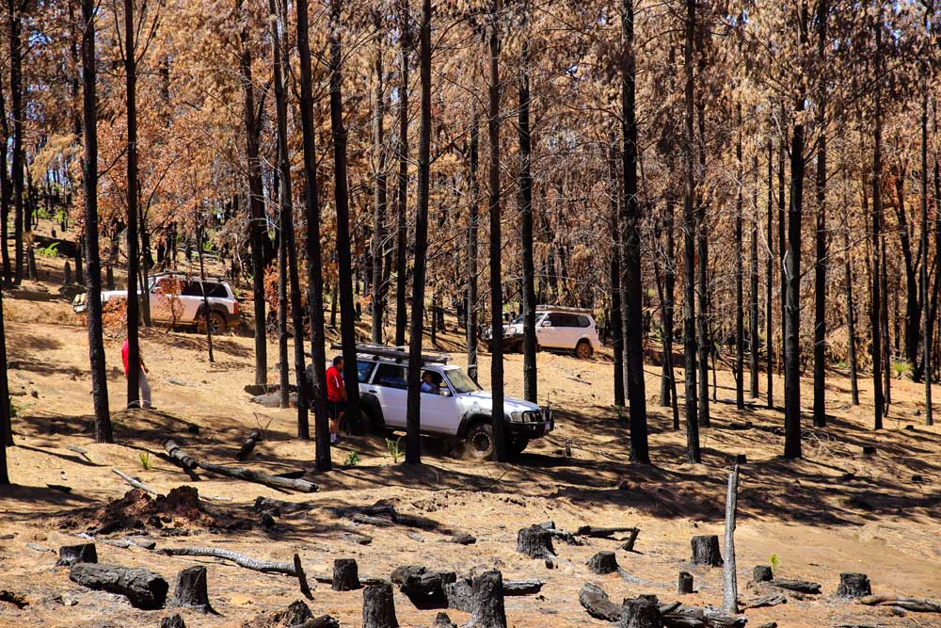

Smaller challenges awaited the convoy further along the track but none proved to be major obstacles. Soon it was time for lunch which was held on the side of a track in the shade of burnt-out pines (see below).

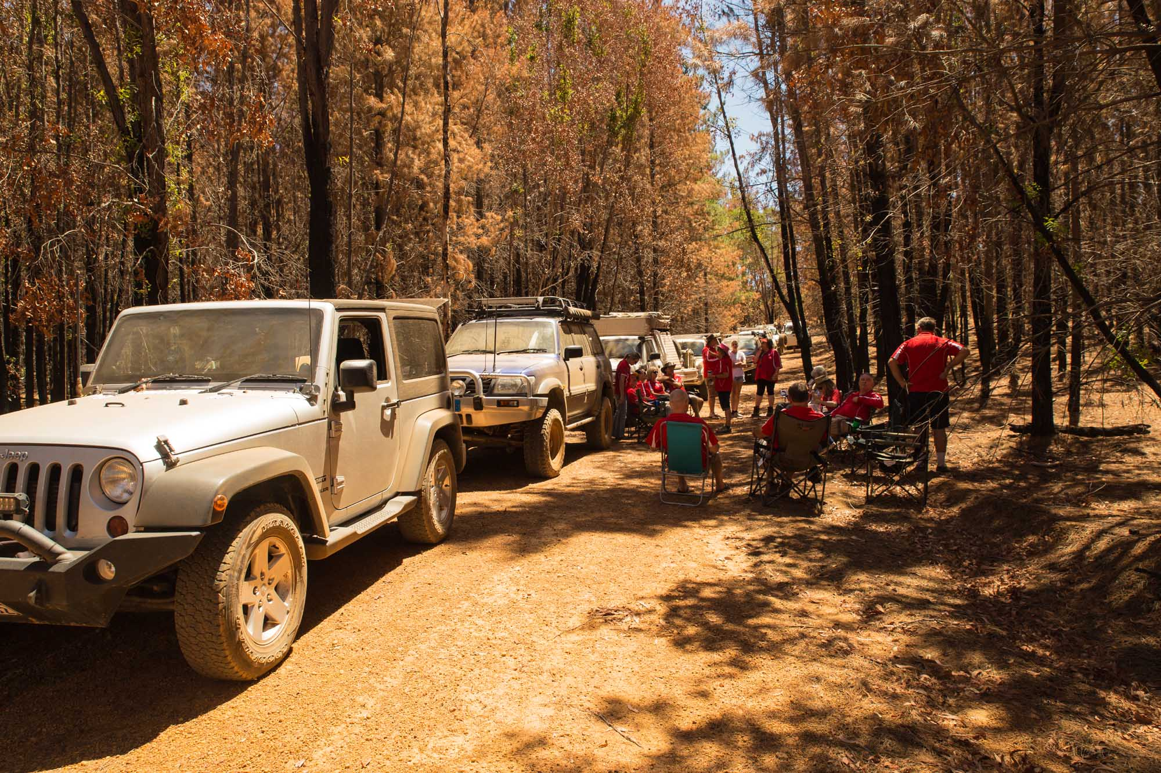

After lunch the convoy drove back towards Great Eastern Highway via Gorey Road. No difficulties were encountered on this part of the run. Around 14:00pm the convoy stopped before the Highway to air-up. Some members chose to drive back to Perth via the powerline track while others left the convoy to drive home. However, Karen, Steve D, Mike, Clare, Steve K and Doug retired to the Chidlow Tavern to enjoy refreshments.

Many thanks to Kerry and Steve for organising and conducting such a challenging and enjoyable day run.

-o0o-

