Lancelin Sand Dunes - 17 Mar 2018
Saturday morning, overcast and cool; we met up at 8:00am at the Carramar Shopping Centre car park. Colin and Paul agreed to be tail end Charlies for the trip, with Chris R; Chris and Robyn; Troy and Marietta; and visitors Barry and Fairlie in the middle; with Mike and Clare leading the convoy.
The trip was also subtitled, the “round-a-bout” trip to Lancelin. That equated to a diversion further west to Marmion Avenue and the navigation of about a thousand round-a-bouts - it felt like that - to Two Rocks Sun City to finally emerge onto the Indian Ocean Drive - a lot of new suburbs all along the way.
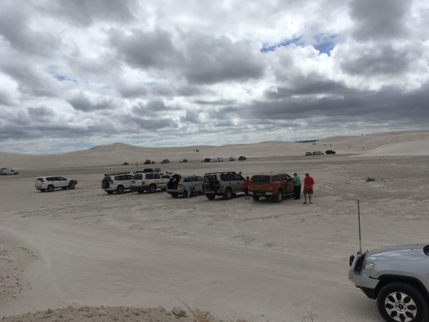
We arrived at the Lancelin Bakery almost right on 10:00am. Good to stretch the legs and have a chat and a feed, before venturing onto the sand dunes.
It seems to be a bit of a tradition these days on arriving at the ‘air down’ area, to find a bogged international visitor in a hire camper van in the only bit of soft sand in that area! So Troy volunteered us to rescue the two young ladies, which we did in quick time with Colin’s trusty Max Trax - little did I know . . .
We aired down and flagged up, and the whole convoy followed Mike and Clare into the crispy white sand dunes - not a lot of other users, but enough for us to be wary.
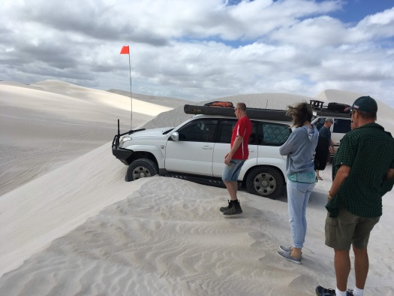
Mike suddenly stopped at the top of a very tall sand dune. Just as well as there was a precipitous drop off the other side and Mike’s front wheels were over the edge – great view though. So not being able to drive forward or back, the first recovery of the day went to Troy and his winch - thanks Troy.
The convoy sought and found some less daunting descents and climbs to practice on. Being the trail blazer Mike decided Max Trax recovery practice for the convoy was in order and voluntarily (?) created another recovery scenario. Chris R thought he should practice too, but did a self-recover - with the obligatory advice from the other members; Ha! Ha!
After practicing for a while we headed off in search of the track north along the coast – where, in the past we could get to Wedge Island - access further on is now denied.
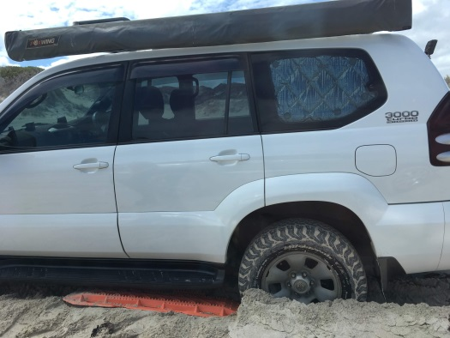
One of the tracks led onto the beach. Err . . . very soft here; keep your distances and keep your momentum up. Mike headed for an exit only to stop – big sandy hills everywhere – and reversed back onto the beach where he decided to do some more Max Trax recovery practice! Chris R not to be outdone also decided to do some more practice too.
In hindsight it was only the manual vehicles that got to practice - but only real men drive manual 4WDs, right?! - the auto transmission vehicles with the right air pressure in their tyres and sufficient revs did make the beach driving look easy though - did I write that out loud?!
We found a different off-beach track on the way back, which included a typical coastal-track sand hill to navigate, complete with gouged out holes at the top from previous vehicles spinning their tyres digging up the track. The convoy climbed and bounced its way over the top – all good.
It was time for lunch and apart from one more very brief fling on a low dune for some, the convoy aired up, downed flags and exited the sand dune 4wd area to have lunch in the park back in Lancelin.
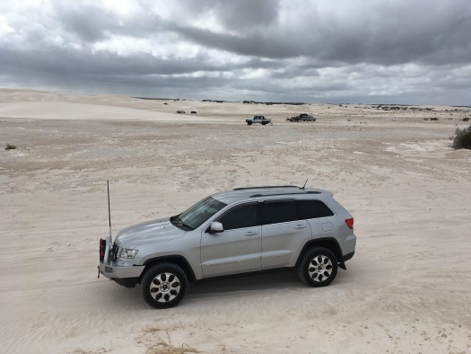
The weather had stayed fine with a ‘gentle’ southerly wind to keep us company, which allowed for a pleasant day of making ‘friends with the Lancelin Sand Dunes’ - with stories to tell and bragging to do.
I enjoyed myself and so did Clare though not very happy with the sand in the Prado, hair and clothes - I should have wound my window up a few more times!
I hope everyone had a good day and, will have another good ‘grandpa’ story to tell next time!?
Great company, thanks for coming.
Mike and Clare
PS: Chris R is still waiting for the car cleaning quote from Robyn . . .

