FAWCETT TRACK TRIP - 18th February 2018
Trip Leaders: Kerry and Steve
Convoy: Kerry and Steve
Mike and Clare
Doug and Winona
Jan and Terry
Troy and Marietta (tail end Charlie)
Chris
Steve
Scott (visitor)
Hertha and Andrew

Report By: Hertha and Andrew

The Convoy (except for Terry and Jan) assembled at the Pinjarra Railway Station where we socialised and Kerry gave us a rundown on what to expect for the day. At 8.30 we headed off in a south easterly direction towards Dwellingup. A short while later we passed the Pinjarra Airstrip and spotted a motorised hang glider in mid flight. Mike informed us that he used to do such dare devil things some 20 years ago. Clare must keep him under control now!!

Passing thru’ Dwellingup we noticed some “Bikers” and the “Bikies” were having their morning coffee in separate cafes, of course, and on opposite sides of the street. We headed into the Lane Poole camping area to meet up with Terry and Jan who were staying there in their Caravan.

We headed further into the Lane Poole Reserve, turned onto the Fawcett Track and travelled a few kms to a nice little clearing where we aired down and enjoyed a morning tea break. The track is named after Captain Fawcett, an early settler, who explored the area looking for farming land. Captain Fawcett’s descendants requested that the authorities maintain the track to commemorate his achievements. It is now a very popular 4WD Track.

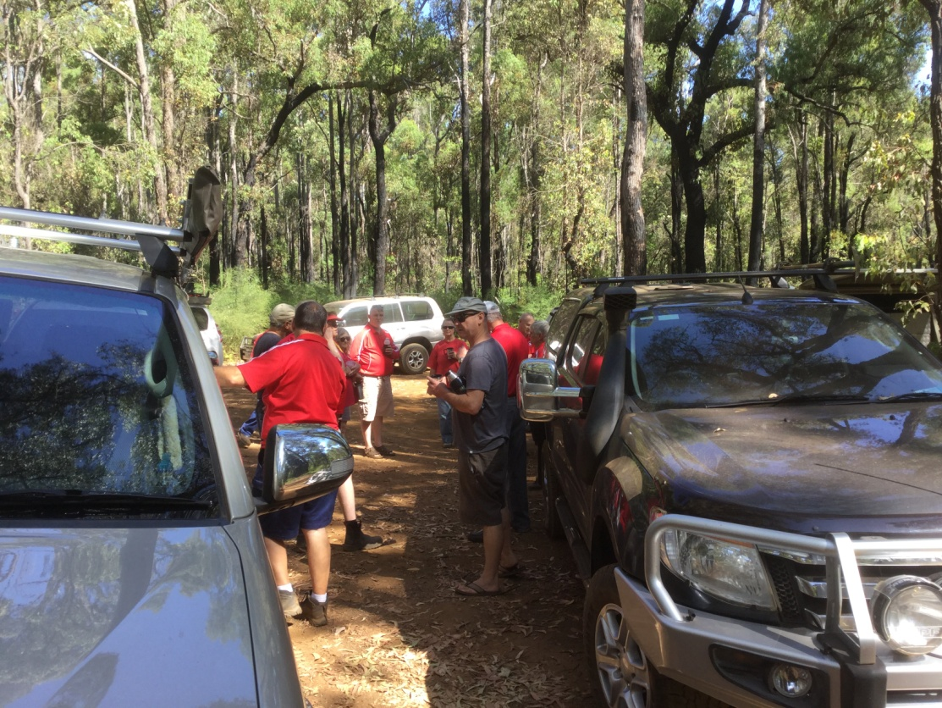

Unfortunately, in the two weeks since Kerry and Steve reccied the trip some of the more difficult sections of the track had been “maintained and improved” by filling the washaways with tennis ball size “cobble stones” so now less challenging. However there were still some challenging and interesting sections to navigate, including a couple of trees across the track, that we had to detour around, and some quiet narrow and overgrown areas. It was obvious from the ruts and washaways that this track would be very slippery and difficult after rain.

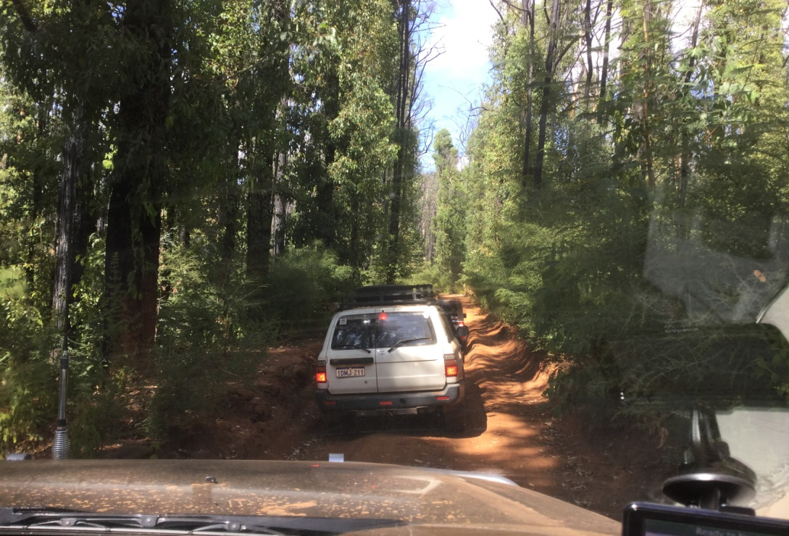

We meandered a little further and then turned down a side track which took us to a nice clearing beside the river with room for all vehicles and plenty of shade. This must be quiet a popular spot as there was remnants of a large camp fire in the clearing. There were a few bugs about and we noticed Steve was keeping them at bay with his fly swatter. Kerry and Steve told us that they found this spot by chance, on the reccie, when they got hungry and took the next turn towards the river.

Right thru’ the trip we noticed the proliferation of white/cream flowers on the Marri trees. According to a couple of members, there Grandfathers said that when Marri trees blossomed so strongly it meant we would have a wet winter.

Arriving at the T-junction of Harvey Quindanning Road, we pumped our tyres up and then headed for the Quindanning Pub, looking forward to a nice cool drink. Unfortunately, ahead were some roadworks - bitumen sealing – and along with at least another dozen vehicles, we were held up for about 20 minutes. Next stop was to view the Alcoa conveyor, where it crossed under the road, carrying bauxite to their Pinjarra Plant. Finally to the Quindanning Hotel for a very refreshing drink.

Everyone departed the Pub around 3.30 and headed home. Our total distance travelled (from Ellenbrook and back) was around 300 km.

Thanks to Kerry and Steve for organising an excellent trip and to Troy and Marietta for assisting with the reccie. There were no problems or recoveries to report.

